**Dungeon crawler**

Game description:

User segment:

Game-helper app:

# 

# Game description:

A basic *dungeon crawler*. The objective is to complete different kinds of levels with different difficulties and different tasks.

You start off simple, with your starting character, low-tier items, and easier hordes of enemies.

As you progress from level to level, you get harder enemies, and more technical weapons.

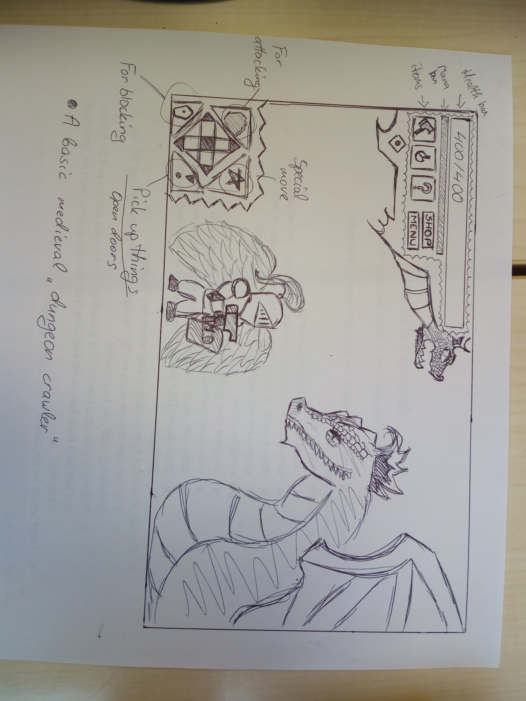

## User segment:

This game is for everyone who likes dungeon crawlers.

The player has to make his or her way into different kinds of dungeons with different threats/tasks.

The controls are simple to use.

#### 

### Game-helper app:

**An app for helping you get used to the game itself and customize your character.**

**An app you need to have to fully embrace the game (insert name)**

**You need to get this app for**

**Get 100% out of the game.**

#### Figma

<https://www.figma.com/file/xavfgw0xIFwa3lEPmAMCVc/Untitled?node-id=0%3A1>